# GLAB 330.2.2 - Standard Deviation

# 

**Introduction: See John’s work on page 3**

**Standard Deviation** **(*σ*)** in statistics, typically denoted by **σ**, is a measure of how much a data set varies (dispersion) between values in a set of data. The lower the standard deviation, the closer the data points tend to be to the mean (or expected value), **μ**. In this lab, we will demonstrate how to calculate the standard deviation.

## Learning Objective:

By the end of this lab learners will be able to calculate the standard deviation.

**Given Dataset**

Imagine that we have the following data set representing the number of books read by five learners in a month:

|  |
| --- |
| **Number of Books (X)** |
| 2 |
| 4 |
| 4 |
| 4 |
| 5 |
| 5 |
| 7 |
| 9 |

**Instructions:**

Here are the steps to calculate the standard deviation:

1. **Calculate the mean (average) of the data set:**



1. **Calculate the squared differences from the mean for each data point:**

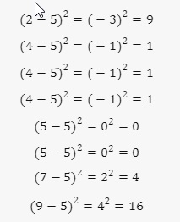

1. **Calculate the average of these squared differences (variance):**

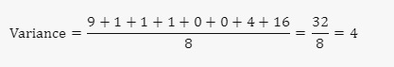

1. **Take the square root of the variance to get the standard deviation:**

## 

The standard deviation of the number of books read by these students is **2**. This means that on average, the number of books read by each student deviates from the mean by **2** books.

**Height of group members (in inches):**

58, 62, 72, 74, 67, 72, 68, 64

1. Calculate the mean (average) of data set

(58 + 62 + 72 + 74 + 67 + 72 + 68 + 64) / 8 = 67.125

1. Calculate the squared differences from the mean for each data point:

(58 - 67.125)2 = (-9.125)2 = 83.265625

(62 - 67.125)2 = (-5.125)2 = 26.265625

(72 - 67.125)2 = (4.875)2 = 23.765625

(74 - 67.125)2 = (6.875)2 = 47.265625

(67 - 67.125)2 = (-.125)2 = 0.015625

(72 - 67.125)2 = (4.875)2 = 23.765625

(68 - 67.125)2 = (0.875)2 = 0.765625

(64 - 67.125)2 = (-3.125)2 = 9.765625

1. Calculate the average of these squared differences (variance):

(83.265625 + 26.265625 + 23.765625 + 47.265625 + 0.015625 + 23.765625 + 0.765625 + 9.765625) / 8 = **26.859375**

1. Take the square root of the variance to get the standard deviation:

sqr(26.859375) = **5.18260311040697**

**Canvas Submission Instructions:**

* Upload your project to your GitHub account without setting it to private.
* Utilize the `README` file for any necessary additional instructions.
* Incorporate suitable comments throughout your project.
* Share the GitHub link on Canvas by clicking on the "Start Assignment" button located in the top-right corner of the Assignment page.